System and Software Architecture Description (SSAD)

E-Lock Box

Team 05

Weiyi Zhong Prototyper
Woom Kim System Architect
Cecilia Jou II V&V
Dejie Meng Requirement Engineer
Qiutong Song Opertaional Concept Engineer
Azuka Okuleye Feasibility Analyst
Chen Gui Project Manager & Life Cycle Planner

UCS-CSSE

Dec.7nd 2013

Version History
Date | Author | Version | Changes made | Rationale
10/15/13 | Woon Kim, Dejie Meng | 1.0 | - Add Section 1 and Section 2 | - Initial Draft SSAD
10/23/13 | Woon Kim, Dejie Meng | 1.1 | - Modify Section 1 and Section 2 | - SSAD for FC package
10/28/13 | Woon Kim, Dejie Meng | 1.2 | - Modify Section2 | - Added more use case and changed use case diagram as well as artifacts and information diagram
11/28/13 | Woom Kim, Dejie Meng | 2.0 | - Change Template  - Modify Section 2  - Adding Section 3 | - We use VPUML to generate all elements in the SSAD  - Added more use case and changed some use case description  - Added software class diagram and hardware class diagram
12/02/13 | Woom Kim, Dejie Meng | 2.1 | - Modify Section 3  - Adding Section 4  - Adding Section 5 | - Modified diagrams in section 3  - Added diagrams in section 4 and rationale in section 5
12/07/13 | Woom Kim, Dejie Meng | 2.2 | - Modify ER diagram  - Modify design class diagram  - Modify Section 5 | - Add more detail and right some wrong in the ER diagram  - Add more detail and relation in design class diagram  - Compare framework in the section 5

Table of Contents
System and Software Architecture Description (SSAD) i
Version History ii
Table of Contents iii
Table of Tables iv
Table of Figures v
1. Introduction 1
1.1 Purpose of the SSAD 1
1.2 Status of the SSAD 1
2. System Analysis 2
2.1 System Analysis Overview 2
2.2 System Analysis Rationale 23
3. Technology-Independent Model 24
3.1 Design Overview 24
3.2 Design Rationale 28
4. Technology-Specific System Design 29
4.1 Design Overview 29
4.2 Design Rationale 36
5. Architectural Styles, Patterns and Frameworks 37

Table of Tables
Table 1: Actors Summary 3
Table 2.1: ER Diagram Summary 5
Table 3: Hardware Component Description 25
Table 4: Software Component Description 25
Table 5: Design Class Description 27
Table 6: Hardware Component Description 29
Table 7: Software Component Description 30
Table 8: Design Class Description 32
Table 9: Architectural Styles, Patterns, and Frameworks 37

Table of Figures
Figure 1: System Context Diagram 3
Figure 2.1: ER Diagram 5
Figure 3.1: Process Diagram 9
Figure 4: Hardware Component Class Diagram 24
Figure 5: Software Component Class Diagram 25
Figure 6: Deployment Diagram 26
Figure 7: Design Class Diagram 27
Figure 8: Hardware Component Class Diagram 29
Figure 9: Software Component Class Diagram 30
Figure 10: Deployment Diagram 31
Figure 11: Design Class Diagram 32
Figure 12: Process Realization Diagram: Upload Document 34

Introduction

Purpose of the SSAD

The purpose of this SSAD is to record the architecture of e-lock box system including detailed diagram of how system will work and be organized according to according to operational concept and requirements. The programmers and developers of our team can use this SSAD as reference to the architecture of the system that we are developing.

Status of the SSAD

This SSAD is version 2.2, which we added more specific detail and correct some relation mistake in the ER diagram and finish the summary. Also, we added more detail in the design class diagram, including involving more controllers and boundaries and entities into the diagram. All of these improvements are based on version 2.1.

System Analysis

System Analysis Overview
<< This section should include a short description of the purpose of the system being developed
The following is an example from the CSC Volunteer Tracking project:
The primary purpose of the Volunteer Tracking System is to track the performance of volunteers working at the California Science Center. The Volunteer Tracking System keeps track of the number of hours that each volunteer has completed and of communications and job requests between and among volunteers, supervisors, and the volunteer coordinator. The system generates reports and certificates based on the needs and preferences of the volunteer coordinator and the CSC's managers. Notifications are sent to the volunteer coordinator once volunteers' working hours meet certain levels required for special recognition. >>
The primary purpose of the Living Advantage’s new website is to store foster youths’ personal information such as birth certificate, student id, and driver’s license safely so they can have access to their documents as they want. Also, foster youths are treated as limited users. There are case managers who help fosters. They keep track of all information of what they have done on foster youths like uploading personal information and tracking history. Administrators will manage all users, files and cases in the system.

System Context
<< This section should contain the system's context, in the form of a UML Class Diagram showing the actors and their relations to the system. More information and example can be found in ICM EPG> Task: Analyze the Proposed System >>
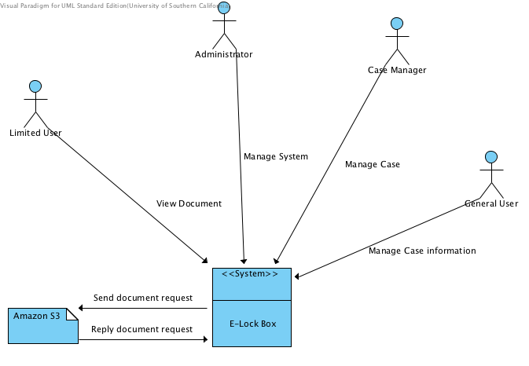
Figure 1: System Context Diagram

<< For each actor shown in the UML Class Diagram:
- The (role) name of the actor
- A description of the actor's relation to the system being developed
- A list of the actor's responsibilities with respect to the design, implementation, installation, and use of the system being developed. >>
Table 1: Actors Summary
Actor | Description | Responsibilities
Limited user (Foster Youth) | Users who use this system to store their vital document | View their vital document
Case manager | Users who mainly responsible for limited user. | Help foster youths  Upload document  Keep track of responsible youth
Administrator | Users who control every other users and files in the system. | Manage all users  Manage all documents  Manage all cases
General User | Users who has limited authority to the system | View case information  Assist case manager and administrator to record the activities

Artifacts & Information
<< This section of the document describes the artifacts and information created by the system. These artifacts can either be used by the end user or reused by the system to produce further artifacts.
This section should contain:
- a UML class diagram showing the artifacts that the system being developed will inspect, manipulate, and/or produce
- and for each artifact shown in the UML class diagram, the artifact's name and its purpose.

More information and example can be found in ICM EPG> Task: Analyze the Proposed System. >>

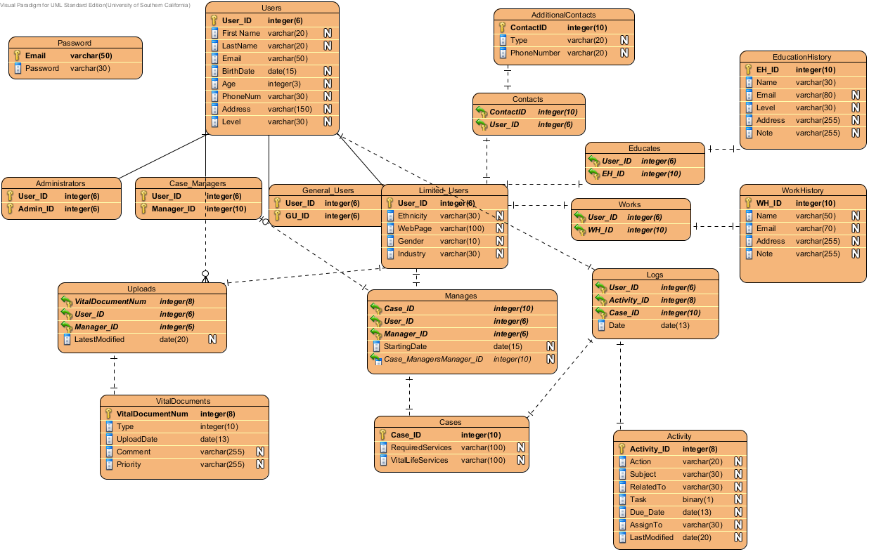
Figure 2.1: ER Diagram
Table 2.1: ER Diagram Summary
Table Name | Description
Password | It only contains users email address and password. The password will be encrypted
Users | Users can be four different type, Administrators, Case manager, general users, and limited users. It contains basic information about Uers such as first name, last name, etc.
Administrator | It shows who the administrators are
Case manager | It shows who the case managers are
General users | It shows who the general users are
Limited users | It shows who the limited users are
Uploads | It shows which managers or administrators upload limited user’s vital document
Vital Documents | It contains vital documents and type and which date the file is uploaded
Manages | It contains which case manager manage a limited users
Cases | It contains information about the cases
Contacts | It shows which users has which contact lists
Additional contacts | It shows additional information about the limited users
Activities | All activities such as upload, email contact updated in the table
Logs | It contains which case manager, administrator made contacts limited users
Education History |  | Limited user’s education history will be stored in here
Educates |  | It contains the relationship between education history and limited user
Work history |  | Limited user’s education history will be stored in here
Works |  | It contains the relationship between work history and limited user

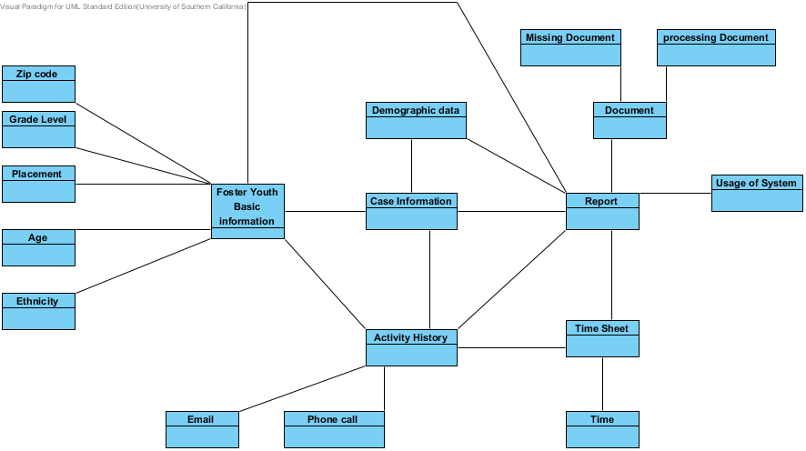
Figure 2.2 Artifacts and Information Diagram
Table 2.2 Artifacts and Information Diagram Summary
Artifact | Purpose
Missing document | It shows total amount of social security card, birth certificates, CA IDs and immunizations are missing
Processing document | It shows total amount of social security card, birth certificates, CA IDs and immunizations are in foster youth’s possession.
Contact information | It contains what a case manager has done in certain period time such as how long the case manager contacted with foster youth.
Age | It calculates age for data report and reports total number of each age.
Usage of System | It is a report that shows monthly and Bi-Annual usage of the system.
Time | It shows the actual time provided by the system clock.
Placement | This report will contain how many placement youth have had.
Ethnicity | It contains total number of foster youth for each ethnicity and the report must be ordered as highest number of foster youth to lowers.
Zip code | It will show the all zip codes that are in the database and display in a chart about zip code and the number of foster youth who lives in the zip code.
Demographic data | It will show the number of limited user in certain area.
Foster youth basic information | It will shows the basic information of a foster youth not just including the zip code, age, placement, grade level etc., also has the name, contact, email, address and so on.
Case information | Each case will represent a foster youth. In the case information, it shows the foster youth basic information, activity history, vital document record, report record and so other information.
Activity History | It shows the contact between a case manager and a foster youth. Activity so far includes email and phone contact. Each activity will have a time stamp.
Report | It shows the data from system. The report will be generated automatically from the system and the content of the report will be chose by who generate the report.

Behavior
<< This section should contain:
- One or more UML Use-Case Diagrams showing the processes whereby actors and the system interact in order to accomplish a goal that benefits at least one of the actors.
- For each use case shown in the UML use case diagram(s):
- The assigned identifier (name) of the use case
- The purpose of the use case
- The requirement(s) listed in the SSRD that are (completely or partially) covered by the use case.
- The risks associated with developing/implementing the use case.
- The pre-conditions for invoking the use case
- The post-conditions that exist after the use case has been completed
- English descriptions of the use case's standard (sunny day) course of action and its alternate (rainy day) course(s) of action.
More information and example can be found in ICM EPG> Task: Analyze the Proposed System. >>

Use cases grid:
ID | Name | Primary Actors | Supporting Actors
UC01 | View Document | Limited User  Case Manager  Administrator
UC02 | Edit Case | Case Manager  Administrator
UC03 | Inactivate User | Administrator
UC04 | Create New Case | Case Manager  Administration
UC05 | Report Generation | Case Manager  Administrator
UC06 | Edit User | Administrator
UC07 | Activate | Administrator
UC08 | Upload Document | Case Manager  Administrator
UC09 | Reset Password | Case Manager  Administrator
UC10 | Check Case Information | General User  Administrator  Case Manager
UC11 | Create High Level User | Administrator
UC12 | Log Activity | General User  Administrator  Case Manager
UC13 | Create A Limited User | Case Manager  Administrator

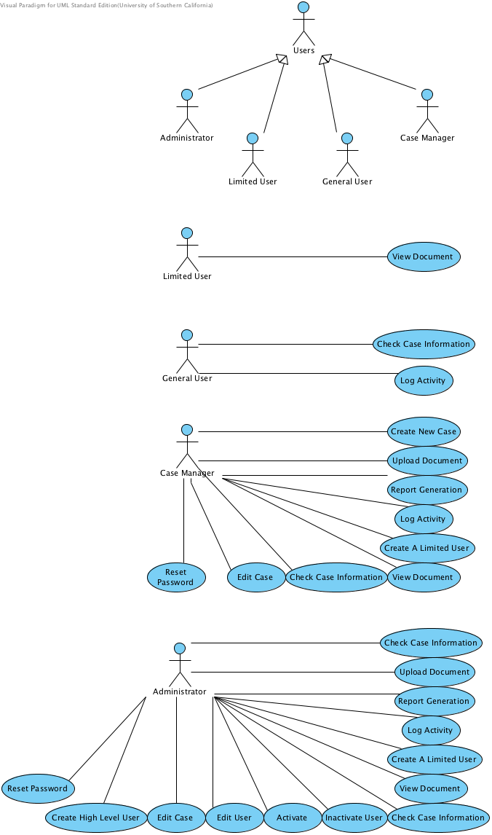
Figure 3.1: Process Diagram

Capability x

Check Case Information

Use Case Descriptions
Main
Super Use Case
Author | dejiemen
Date | Nov 27, 2013 1:35:07 PM
Brief Description | Administrator, case manager and general user can see the case information of a foster youth
Preconditions | 1. Only administrator, case manager and general user can check case information  2. Administrator, case manager and general user has logged into the system
Post-conditions | 1. System will return the page of case information  2. Return unauthorized action information
Flow of Events
   | Actor Input | System Response
  1 | [Administrator and case manager and general user]  Click a specific case
  2 |  | Send request to case database
  3 |  | Return the case information page

Reset Password

Use Case Descriptions
Main
Super Use Case
Author | dejiemen
Date | Nov 27, 2013 2:41:19 PM
Brief Description | If administrator and case manager want to change their password of the system, they can reset the password. Other kind of user wan to change the password, they need to contact case manager or administrator.
Preconditions | 1. Only administrator and case manager can reset password  2. Administrator and case manager should login to the system  3. Reset password can only happen in the case management page
Post-conditions | 1. New password will be refreshed into the database and return reset succeed message  2. Return invalid information  3. Return unauthorized action information
Flow of Events
   | Actor Input | System Response
  1 | [Administration and case manager ]  Click "Reset password"
  2 |  | Validate the role of user
  3 |  | If validate failed, return unauthorized action information
  4 |  | If validate succeed, return password reset page
  5 | Type in the new password and click "Submit"
  6 |  | Validate the information from password reset page
  7 |  | If validate failed, return invalid information message
  8 |  | If validate succeed, refresh the new password into the database and return reset succeed message
  9 |  | Return to case management page

Create High Level User

Use Case Descriptions
Main
Super Use Case
Author | dejiemen
Date | Nov 27, 2013 2:17:51 PM
Brief Description | When other people want to get into the system as a case manager or general user or administrator, administrator can create such high level user in the system.
Preconditions | 1. Only administrator can create high level user in the system  2. Administrator has logged into the system  3. Create a high level user can only happen in the user management page
Post-conditions | 1. A new user will be created in the system and inserted into user database.  2. Return invalid information  3. Return unauthorized action information
Flow of Events
   | Actor Input | System Response
  1 | [Administrator]  Click "Use Management"
  2 |  | Validate the role of user
  3 |  | If validate failed, return unauthorized action information
  4 |  | If validate succeed return user management page
  5 | Click "Create user"
  6 |  | Return a user information page
  7 | Type in the information and click "Submit"
  8 |  | Validate the information from user information page
  9 |  | If validate failed, return invalid information message
  10 |  | If validate succeed, insert the user into user database

Edit Case

Use Case Descriptions
Main
Super Use Case
Author | dejiemen
Date | Nov 27, 2013 2:32:24 PM
Brief Description | If some information of foster youth has changed, administrator and case manager can edit the case information of a foster youth
Preconditions | 1. Only administrator and case manager can edit case information  2. Administrator and case manager should login to the system  3. Edit case should only happen in the case information page
Post-conditions | 1. New case information will be refreshed into the database  2. Return invalid information message  3. Return unauthorized action information
Flow of Events
   | Actor Input | System Response
  1 | [Administrator and case manager]  Choose a specific case
  2 |  | Send request to case database and receive the case information
  3 |  | Return a case information page
  4 | Click "Edit"
  5 |  | Validate the role of user
  6 |  | If validate failed, return unauthorized action information
  7 |  | If validate succeed, return a case information page for editing
  8 | Type in the new case information and click "Submit"
  9 |  | Validate the information from case information page
  10 |  | If validate failed, return invalid information message
  11 |  | If validate succeed, refresh the new information into database
  12 |  | Return a new case information page

Edit User

Use Case Descriptions
Main
Super Use Case
Author | dejiemen
Date | Nov 27, 2013 2:25:19 PM
Brief Description | If some information of high level user has changed, administrator can change the information of high level user
Preconditions | 1. Only administrator can edit user information  2. Administrator should login the system  3. Edit user can only happen in the user management page
Post-conditions | 1. New user information will be refreshed into the database  2. Return invalid information  3. Return unauthorized action information
Flow of Events
   | Actor Input | System Response
  1 | [Administrator]  Click "User Management"
  2 |  | Validate the role of user
  3 |  | If validate failed, return unauthorized action information
  4 |  | If validate succeed, return user management page
  5 | Click a specific user
  6 |  | Send request to user database and return the user information page
  7 | Click "Edit"
  8 |  | Return a user information page for editing
  9 | Type in new information and click "Submit"
  10 |  | Validate the information from user information page
  11 |  | If validate failed, return invalid information message
  12 |  | If validate succeed, refresh new information into database
  13 |  | Return a new user information page

Activate

Use Case Descriptions
Main
Super Use Case
Author | dejiemen
Date | Nov 27, 2013 2:11:51 PM
Brief Description | If some off system users want to come back system, administrator can activate corresponding user
Preconditions | 1. Only administrator can activate a user  2. Administrator has logged into the system  3. Activate a user can only happen in the user management page
Post-conditions | 1. A user will be successful activated in the system  2. Return unauthorized action information  3. Return wrong action message
Flow of Events
   | Actor Input | System Response
  1 | [Administrator]  Click "User management"
  2 |  | Validate the role of user
  3 |  | If validate failed, return unauthorized action information
  4 |  | If validate succeed, return user management page
  5 | Select a specific user and click "Activate"
  6 |  | Check the status of user
  7 |  | If the status is activated, return wrong action message
  8 |  | If the status is inactivated, activate the user and change the status of user in the database

Inactivate User

Use Case Descriptions
Main
Super Use Case
Author | dejiemen
Date | Nov 27, 2013 2:03:48 PM
Brief Description | If a user is no longer in the system, administrator can inactivate the user
Preconditions | 1. Only administrator can inactivate user  2. Administrator has logged into the system  3. Inactivate user can only happen in the user management page
Post-conditions | 1. A limited user and the related case will be inactivate in the system, only administrator can see inactivate case and then activate it.  2. Return unauthorized action information  3. Return wrong action message
Flow of Events
   | Actor Input | System Response
  1 | [Administrator]  Click "User management"
  2 |  | Validate the role of user
  3 |  | If validate failed, return unauthorized action information
  4 |  | If validate succeed, return user management page
  5 | Select a specific user and click "Inactivate"
  6 |  | Check the status of user
  7 |  | If the status is inactivated, then return wrong action message
  8 |  | If the status is activated, then inactivate the user and change the status of user in database

View Document

Use Case Descriptions
Main
Super Use Case
Author | dejiemen
Date | Nov 26, 2013 5:23:54 PM
Brief Description | Administrator and case managers and limited users can see the vital document in the system.
Preconditions | 1. Only administrators, case manager and limited user can view the document  2. Administrators or case mangers or limited user have logged into the system
Post-conditions | 1. Users can see the information of the vital document  2. Return unauthorized action information
Flow of Events
   | Actor Input | System Response
  1 | Click a specific document record
  2 |  | Validate the role of users
  3 |  | If validate failed, return unauthorized information
  4 |  | If validate succeed, send doc request to document database
  5 |  | Database return document and generate a preview of document
  6 | Click "Download" or "Print"
  7 |  | Validate the role of users
  8 |  | If validate failed, return unauthorized information
  9 |  | If validate succeed, send request corresponding controller

Create A Limited User

Use Case Descriptions
Main
Super Use Case
Author | dejiemen
Date | Nov 27, 2013 1:15:55 PM
Brief Description | Administrator or case manager can create a limited user so that a foster youth will have an username and password to login to the system
Preconditions | 1. Only administrator and case manager can log an create a limited user  2. Administrator and case manager has logged into the system  3. Create a limited user can only happen in the case information page
Post-conditions | 1. A new user will be generated and the username and password will be recorded in the database and get generate succeed message.  2. Return unauthorized action information
Flow of Events
   | Actor Input | System Response
  1 | [Administrator or case manager]  Click "Create user"
  2 |  | Validate the role of user
  3 |  | If validate failed, return unauthorized action information
  4 |  | If validate succeed, generate a random password related to the username, which is the email address in the case
  5 |  | Insert the new username and password in the user database and send request to case database
  6 |  | Connect case with a limited user and return generate succeed message

Log Activity

Use Case Descriptions
Main
Super Use Case
Author | dejiemen
Date | Nov 27, 2013 1:08:14 PM
Brief Description | Administrator, case manager and general user can log activities related to a foster youth
Preconditions | 1. Only administrator and case manager can log an activity  2. Administrator or case manager has logged into the system  3. Log an activity can only be done in the case information page
Post-conditions | 1. A new record of activity will appear in the case information  2. Return "Description should not be blank" message
Flow of Events`
   | Actor Input | System Response
  1 | [Administrator, case manager and general user]  Click "Add new"
  2 |  | Return activity description page
  3 | Type in the information and click "Save"
  4 |  | Validate the description of activity
  5 |  | If description is blank, return "Description should not be blank" message
  6 |  | If validate succeed, insert activity into case
  7 |  | Update new activity record in case information page

Report Generation

Use Case Descriptions
Main
Super Use Case
Author | dejiemen
Date | Nov 27, 2013 12:57:40 PM
Brief Description | Administrator or case manager can generate different kinds of report to get information from the system
Preconditions | 1. Only administrator and case manager can generate a report  2. Administrator and case manager has logged into the system
Post-conditions | 1. A new report will be generated from the system automatically and can be print and download  2. Return unauthorized action information  3. Return "Report cannot be blank" message  4. Return invalid information message
Flow of Events
   | Actor Input | System Response
  1 | [Administrator and case manager]  Click "Report"
  2 |  | Validate the role of user
  3 |  | If validate failed, return unauthorized action information
  4 |  | If validate succeed, return report generation page
  5 | Choose the kind of report want to generate and type in necessary information
  6 |  | Validate the choice of report
  7 |  | If choice is blank, return "Report cannot be blank" message
  8 |  | If validate succeed, then validate the information from report page
  9 |  | If validate failed, return invalid information message
  10 |  | If validate succeed, send request to case database, document database and user database
  11 |  | Receive information and generate a preview of report
  12 | Click "Print"
  13 |  | Send request to corresponding controller

Upload Document

Use Case Descriptions
Main
Super Use Case
Author | dejiemen
Date | Nov 27, 2013 12:46:39 PM
Brief Description | Administrators or case managers can upload documents for a foster youth in the system
Preconditions | 1. Only administrator and case manager can upload document  2. Administrator or case manager has logged into the system  3. Upload document function only in case information page  4. The paper edition of document has been scanned into the local machine as electrical edition
Post-conditions | 1. A new vital document will be uploaded into the system and a record of new uploaded document will appear in the case information  2. Return invalid document description message  3. Return unauthorized action information
Flow of Events
   | Actor Input | System Response
  1 | [Administrator and case manager]  Click "Add new"
  2 |  | Validate the role of user
  3 |  | If validate failed, return unauthorized action information
  4 |  | If validate succeed, return document upload page
  5 | Choose document and type in the description of the document and click "Submit"
  6 |  | Validate the information of description
  7 |  | If validate failed, return invalid description message
  8 |  | If validate succeed, insert document into document database
  9 |  | Update the case information page with new uploaded document record

Create New Case

Use Case Descriptions
Main
Super Use Case
Author | dejiemen
Date | Nov 27, 2013 12:37:52 PM
Brief Description | Create a new case for a new foster youth of the system. The new case will include the basic information about this foster youth.
Preconditions | 1. Only administrator and case manager can create a new case  2. Administrators or case managers has logged into the system
Post-conditions | 1. A new case will be created into the database and return succeed message  2. Return invalid message for invalid information in the case information page  3. Return unauthorized action information
Flow of Events
   | Actor Input | System Response
  1 | [Administrator or case manager]  Click "Create new case"
  2 |  | Validate the role of user
  3 |  | If validate failed, return unauthorized action information
  4 |  | If validate succeed, return a case information page
  5 | Type in the information and click "Submit"
  6 |  | Validate the information from case information page
  7 |  | If validate failed, return invalid information message
  8 |  | If validate succeed, insert case into case database return succeed message

Modes of Operation

<< For projects involving systems that operate in more than one mode this section should contain a description of the system's behavior in each of its modes. More information and example can be found in ICM EPG> Task: Analyze the Proposed System. >>
The E-Lockbox will operate in only one mode, so nothing further need to be said of modes of operation.

System Analysis Rationale

<< This section should list and explain aspects of the analysis that are deemed by the team to be less than obvious or actually counter-intuitive and for which, as a result, there is a high risk that readers will not understand or will misunderstand what is intended. More information and example can be found in ICM EPG> Task: Analyze the Proposed System. >>
1. Based on how users will interact with system, we want to give the basic description of four different levels of users are available in the E-Lockbox system:
(1) Limited Users: This user will be the foster youth responsible by Living Advantage. User can view their vital files in the system and contact case manager offline when it’s necessary.
(2) Case managers: This user can upload vital files for foster youth and view foster youth’s files. Also, the case managers can help foster youth when they need help, and track history, generate report.
(3) Administrators: This user is the highest level of authority in the system. User will be responsible to manage other users, files and cases in the system including activate and deactivate files, cases and users etc.
(4) General user: This user will be able to view case information, which not include the information of vital files of foster youths.

2. According to the system context diagram and user case diagram, we want to make following explanation:
(1) Each manipulation of each role according to system context diagram may correspond to many user cases listed from 2.1.3.1, which the user cases start from 2.1.3.1 will not be the whole of this system. We will update more user cases based on new version of operational concept, requirements and prototype.

Technology-Independent Model

Design Overview

System Structure
<< This section should contain
- a UML hardware component class diagram
- a UML software component class diagram
- a UML deployment diagram
- If necessary, a class diagram for the system's supporting software infrastructure
- and descriptions of the hardware components, software components, and, if necessary, the supporting software infrastructure components of the technology/platform-independent system architecture
More information and example can be found in ICM EPG> Task: Define Technology-Independent Architecture >>

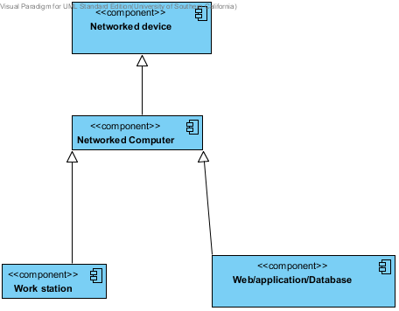
Figure 4: Hardware Component Class Diagram

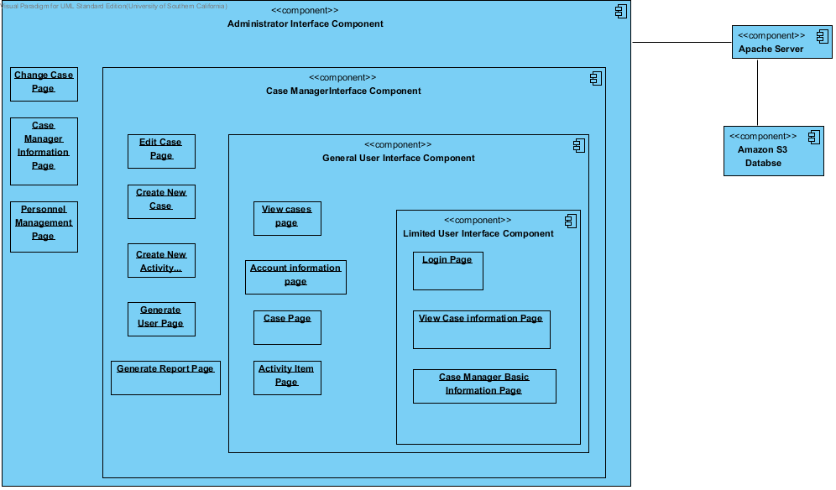
Figure 5: Software Component Class Diagram
Table 3: Hardware Component Description
Hardware Component | Description
Networked Computer | It is a server that receive requests from Client and response the request
Work Station | Work station is a station that a client runs. It request to the server. It includes google chrome.
Web/application/database

Table 4: Software Component Description
Software Component | Description
Login Page | User can Login through this page
View Case Information Page | It contains the information about the case of the chosen limited user.
Case Manager Basic Information Page | It contains the information about the case manager who controls a case
View Cases Page | It contains list of the cases that can be clicked to view detail
Account Information Page | It contains the logged in user’s information and the user can update and change their password
Case Page | It contains all information for a foster youth including contact information, education and work history and vital document records
Activity Item Page | It contains all activity information
Edit Case Page | Case Manager and Administrator can edit the case page
Create New Case Page | Through this page, selected user can create new case.
Create New Activity Page | It can create new activity.
Generate User Page | It can create new user
Generate Report Page | Selected users can create report about the limited users’ demographic, etc.
Case Manager Information Page | It contains a selected case manager’s information.
Personnel Management Page | It contains all users’ information. Through this page, administrator can activate, or deactivate user accounts

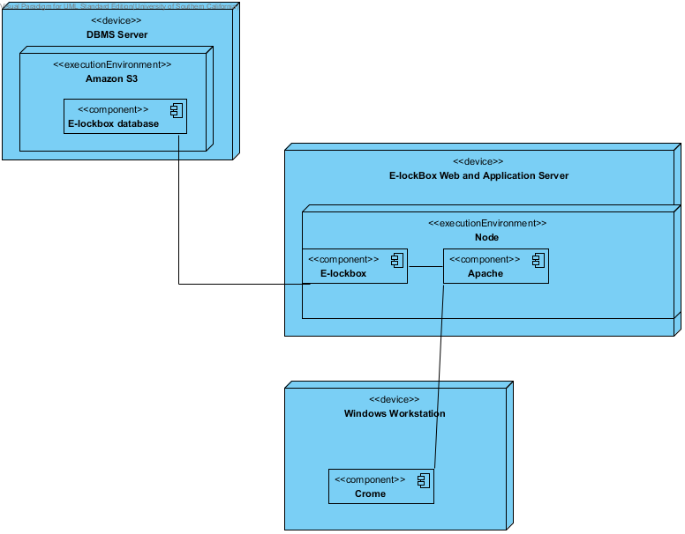
Figure 6: Deployment Diagram

Design Classes
This section should contain:
- UML class diagrams showing all the boundary, entity, and control classes in the design of the system being developed
- and a description of each class in the diagram
More information and example can be found in ICM EPG> Task: Define Technology-Independent Architecture >>

<Classes n>
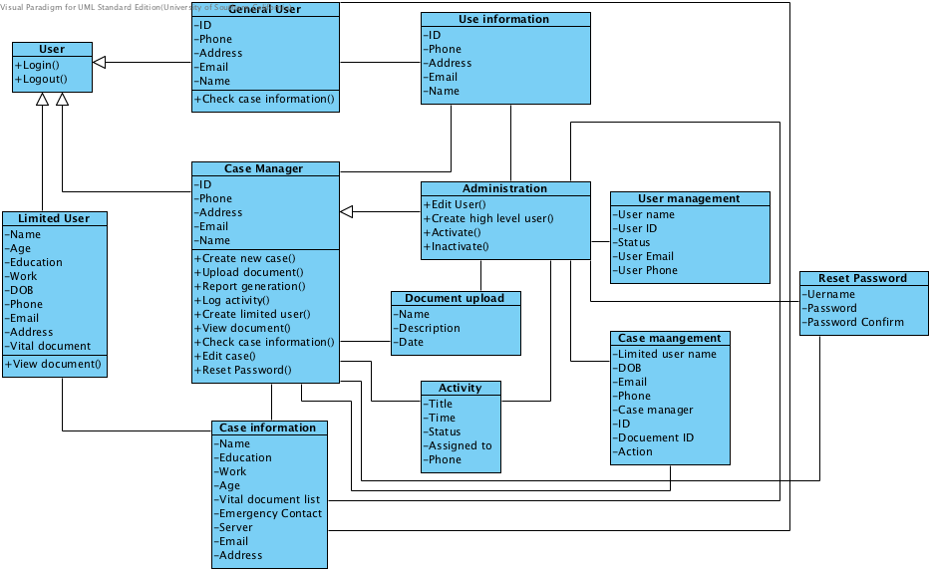
Figure 7: Design Class Diagram

Table 5: Design Class Description
Class | Type | Description
User |  | Any user can login and logout of the system
Limited User |  | Limited user will have his basic information and he only can view document.
General User |  | General user has his basic information and he has limited access to the system
Case manager |  | Case manager will has his basic information and some authorized access to the system
Case information |  | This class will help limited user class to record all necessary information of him.
User information |  | This class will help general user, case manager and administrator to record necessary information.
Administrator |  | Administrator inherit from case manager with adding more access to the system.
Document upload |  | This class will help to record necessary information when uploading a document.
Activity |  | This class will log information of an activity.
User management |  | This class will be used in user management.
Case management |  | This class will be used in case management.
Reset password |  | This class will be used to reset password.

Design Rationale

<< This section should contain an explanation of how/why the architecture/design described in previous sections was chosen. More information and example can be found in ICM EPG> Task: Define Technology-Independent Architecture >>
We designed the system according to different level of access to the system of different kind of user. Each user will have its information, while limited user is the reason we building this system so they will have more specific information in the system. Other classes or pages are used to implement the different level of access and different kind of function of the system according to the requirement from clients.
We deploy the system according to the fact that clients may not be able to supply device to store real data in the system, so we will store the real data in the Amazon and the database we have are mainly contain the index of each kind of data.
We descript software and hardware in high-level abstraction, so we don’t go into the detail of each part. For design class diagram, we just include some basic class in the system, which will be mainly used, and the whole system may be more complicated.

Technology-Specific System Design
<< Once you know specific technology that you team is going to use, design the system and software architecture and document them in this section. >>

Design Overview

System Structure
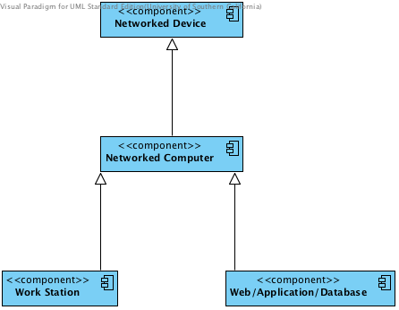
Figure 8: Hardware Component Class Diagram
Table 6: Hardware Component Description
Hardware Component | Description
Networked Computer | It is a server that receive requests from Client and response the request
Work Station | Work station is a station that a client runs. It request to the server. It includes google chrome.
Web/application/database

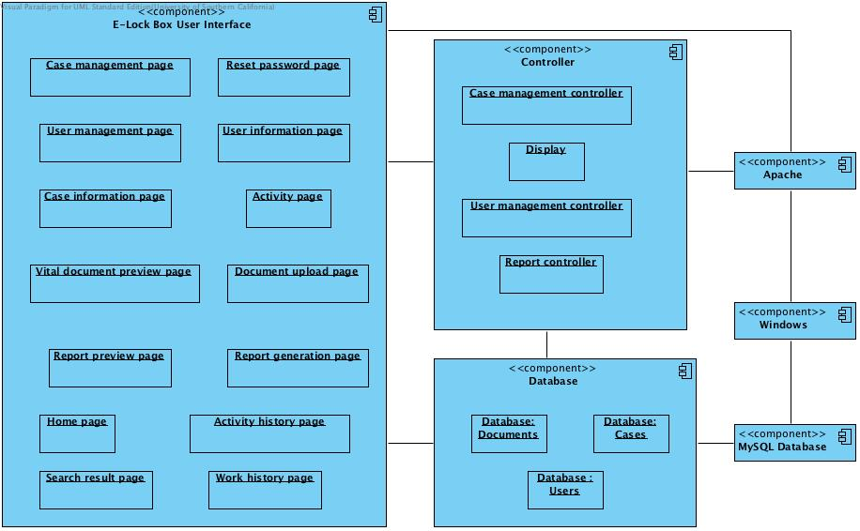
Figure 9: Software Component Class Diagram
Table 7: Software Component Description
Software Component | Description
Case management page | It contains a list of cases that a case manager is responsible for and also it’s the main page when a case manage or administrator or general user login the system.
User management page | It contains a list of users in the system, including their users’ id and status and so on. Only administrator can access it.
Case information page | It contains all necessary information the system need to use for a foster youth, including name, email, phone, address, and education history and so on.
Vital document preview page | It contains screenshot of vital document.
Report preview page | It contains screenshot of generated report.
Home page | It used to login the system by any users.
Search result page | It contains the result of a search.
Reset password page | It contains the necessary information for resetting password, including username, new password and password confirm etc.
User information page | It contains necessary information for a high level user, which means administrator, case manager and general user, including name, phone, and email and so on.
Activity page | It contains the necessary information you need to type in to build a legal activity record.
Document upload page | It contains necessary description for uploaded document and some functions for choosing the document you want to upload.
Report generation page | It contains the type of report you want to generate.
Activity history page | It contains the history of the activities for a foster youth.
Work history page | It contains the history of education of a foster youth.
Case management controller | It used to control all case related workflow in the system. Any message that related to the case needs to deliver to it first.
Display | It used to display different kind of message or information.
User management controller | It used to control all user related workflow, which user only means high-level users.
Report controller | It used to generate report and interact with different kind of database.
Database: Documents | It contains all vital document index
Database: Cases | It contains all cases index
Database: Users | It contains all user index

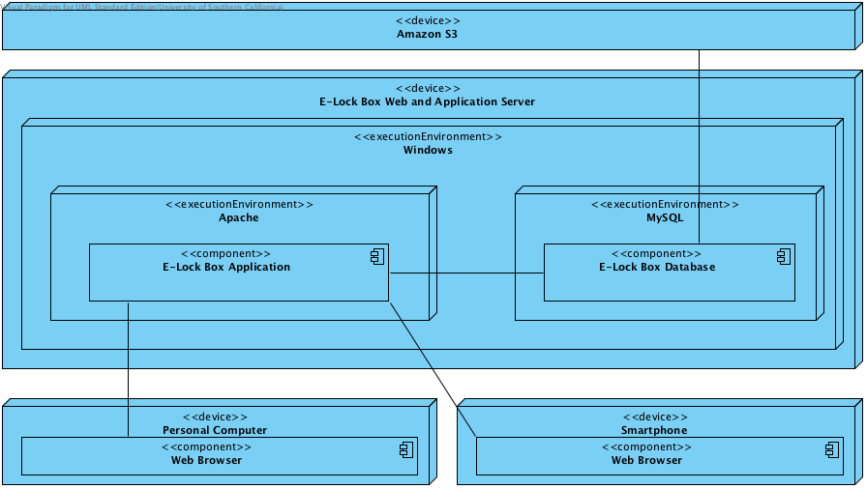
Figure 10: Deployment Diagram

Design Classes

<Classes n>
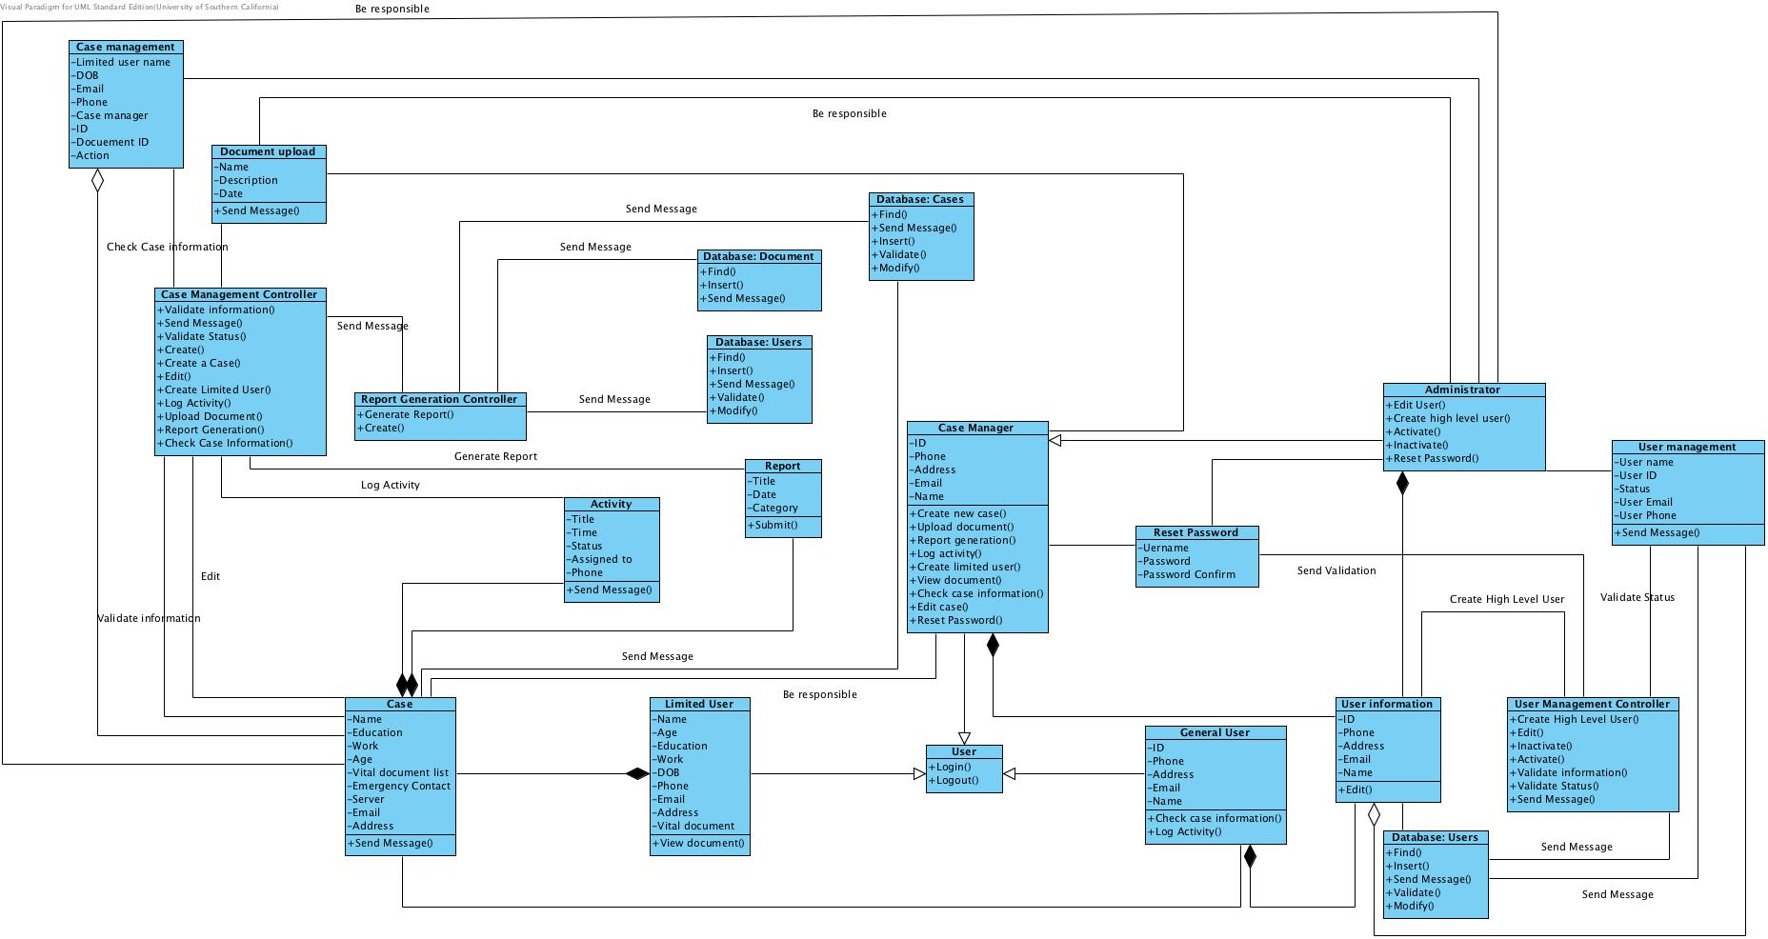
Figure 11: Design Class Diagram
Table 8: Design Class Description
Class | Type | Description
User |  | Any user can login and logout of the system
Limited User |  | Limited user will have his basic information and he only can view document.
General User |  | General user has his basic information and he has limited access to the system
Case manager |  | Case manager will has his basic information and some authorized access to the system
Case information |  | This class will help limited user class to record all necessary information of him.
User information |  | This class will help general user, case manager and administrator to record necessary information.
Administrator |  | Administrator inherits from case manager with adding more access to the system.
Document upload |  | This class will help to record necessary information when uploading a document.
Activity |  | This class will log information of an activity.
User management |  | This class will be used in user management.
Case management |  | This class will be used in case management.
Reset password |  | This class will be used to reset password.
User management controller |  | This is used for dealing with all user related issue.
Case management controller |  | This is used for dealing with all case related issue
Report |  | This class will be used to generate report.
Report controller |  | This is used for generating report related issue
Database: Users |  | This is used to store user entity.
Database: Documents |  | This is used to store vital document entity.
Database: Cases |  | This is used to store case entity.

Process Realization
The process diagram will show some sequence diagram for most risky or important use cases in the system.

Upload Document
This is one of most important use case in the system. If we want to store vital document from foster youth secure, we need this function to upload the document into a safe database.

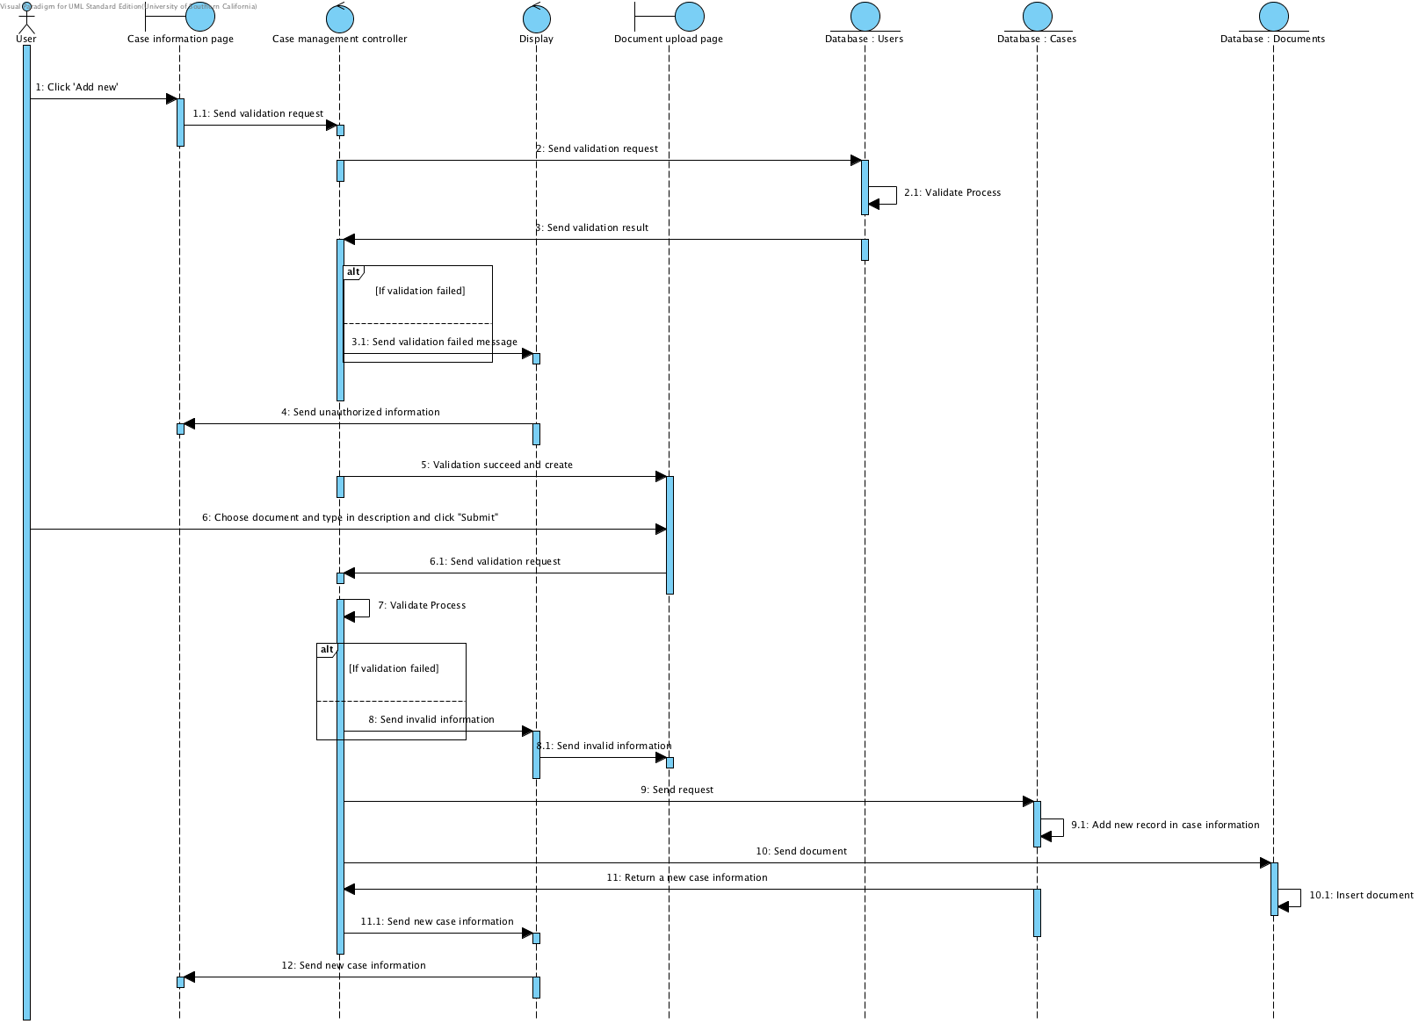
Figure 12: Process Realization Diagram: Upload Document

Create new case
For this use case, it’s one of the highest priorities in the system. When we want to help any foster youth, we need to create a case for him or her and then track case information. We can have a case without create a related user, which means the related foster youth may not be a limited user in the system but once they become a limited user in the system, they will be connected to a exist case.
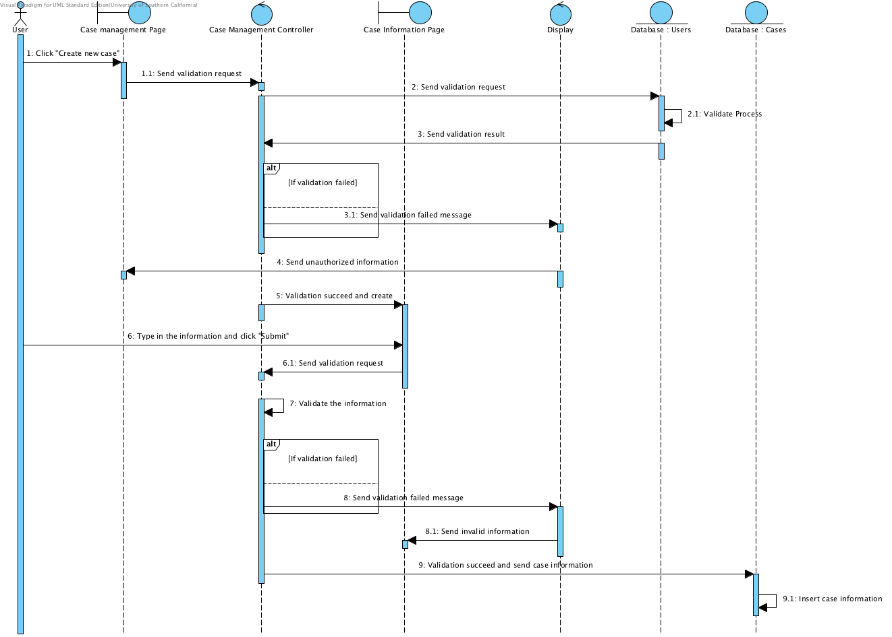
Figure 16: Process Realization Diagram: Create new case

Create high-level user
Create a high level user just like create a case for foster youth, this is the only way to add more people to help foster youth. Also, it’s one of the most priority functions.
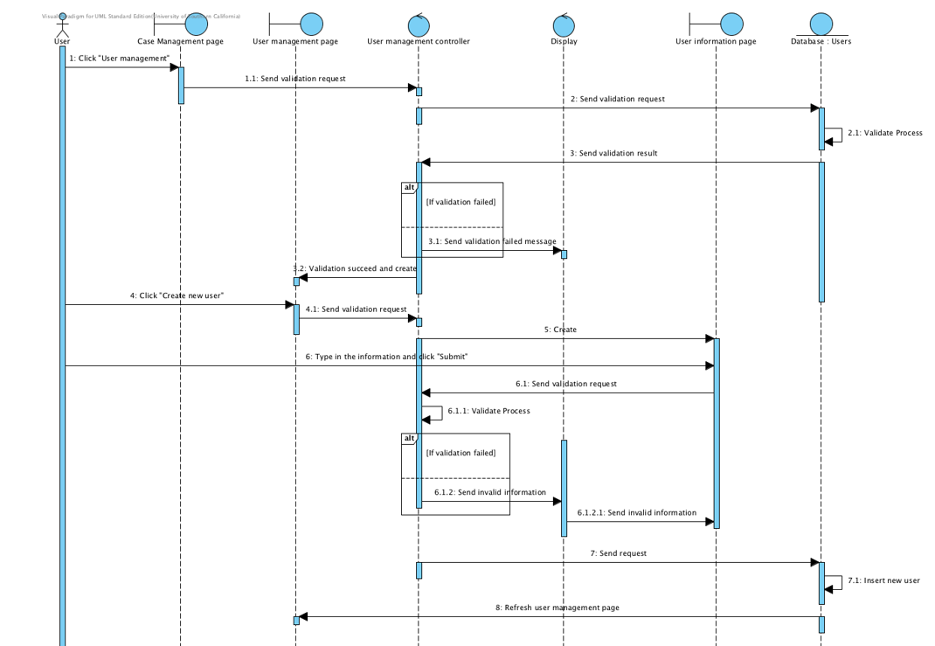
Figure 17: Process Realization Diagram: Create high-level user

Design Rationale
We designed the system according to different level of access to the system of different kind of user. Each user will have its information, while limited user is the reason we building this system so they will have more specific information in the system. Other classes or pages are used to implement the different level of access and different kind of function of the system according to the requirement from clients.
We deploy the system according to the fact that clients may not be able to supply device to store real data in the system, so we will store the real data in the Amazon and the database we have are mainly contain the index of each kind of data.
We descript software and hardware in high-level abstraction, so we don’t go into the detail of each part. For design class diagram, we just include some basic class in the system, which will be mainly used, and the whole system may be more complicated.

Architectural Styles, Patterns and Frameworks
<< Describe any implementation architecture styles (e.g. the Prism style and 3-tier architecture), patterns (e.g. pipe-and-filter and client-server), or frameworks (e.g. Java and CORBA) used to describe the system architecture. >>
Table 9: Architectural Styles, Patterns, and Frameworks
Name | Description | Benefits, Costs, and Limitations
MVC Architecture | Model–view–controller (MVC) is a software architecture pattern, which separates the representation of information from the user's interaction with it. It include model, view and controller in this architecture, following are the descriptions of each:  Controller: A controller can send commands to the model to update the model's state. It can also send commands to its associated view to change the view's presentation of the model.  Model: A model notifies its associated views and controllers when there has been a change in its state. This notification allows the views to produce updated output, and the controllers to change the available set of commands. A passive implementation of MVC omits these notifications, because the application does not require them or the software platform does not support them.  View: View requests information from the model that it needs for generating an output representation to the user. | Benefits:  1. Separation of concerns:  The separation the three components, allows the re-use of the business logic across applications. Multiple User Interfaces can be developed without concerning the codebase.  2. Developer specialization and focus:  The developers of UI can focus exclusively on the UI screens without bogged down with business logic.  Costs:  There is no specific cost required to use MVC architecture.  Limitations:  - Because of the decoupling of MVC, it may increase complexity of the system.  - MVC need multiple programmer and knowledge of multiple programming.  - Inefficiency of data access in view.

